Supplementary Online Material
Supplementary Results
Supplementary Table S1 and S6
Supplementary Figure S1 to S5

Supplementary result
The left OFC is more sensitive to positive consequences
The parametric analysis revealed that the left OFC but not the right OFC is modulated by the magnitude of the experienced outcome. To directly compare the activation in the left and right OFC, we defined an additional ROI in the right OFC, which is the right hemisphere homologue of the left OFC. Three way ANOVA (hemisphere by risk by outcome) revealed a marginally significant interaction between hemisphere and outcome (F(1,12) = 3.62, p = .082), suggesting that the left OFC is more sensitive to reward than is the right OFC.

The ventral putamen is sensitive to reward but not risk
The ventral striatum region also extends laterally to the ventral putamen. To further explore these activations, we defined two additional ROIs centered in the left (MNI: -20 12 -12) and right (MNI: 20 12 -10) ventral putamen. The results indicated that both left and right putamen were sensitive to reward (Left putamen: F(1,12) = 16.56, p = .0016; Right putamen: F(1,12) = 24.21, p < .001), but not to risk (Left putamen: F(1,12) = 1.633, p = .226; Right putamen: F(1,12) = 1.206, p = .294). This suggests that NAcc and ventral putamen may share a similar function in processing reward-related information.

Table S1: Foci of regions modulated by the experienced risk in the parametric analysis
Regions | Voxels | Z | x | y | z
Dorsal Medial Prefrontal Cortex | 438 | 3.59 | 4 | 48 | 26
 |  | 3.57 | 2 | 52 | 30
 |  | 3.20 | 4 | 50 | 12
Thalamus | 297 | 3.29 | -2 | -2 | 4
Right SM/IPL | 329 | 3.2 | 54 | -42 | 34
 |  | 3.08 | 54 | -50 | 46

Note: The image was thresholded using clusters determined by Z > 2.3 and a corrected cluster threshold of p = .05 at the whole-brain level. Z= Z score of peak, x, y and z (in mm) are in Montreal Neurological Institute (MNI) co-ordinates systems.
Abbreviations: SM: supramarginal gyrus; IPL: inferior parietal lobule.
Table S2: Foci of regions modulated by the experienced reward in the parametric analysis
Regions | Voxels | Z | x | y | z
ACC/VMPFC/left LOFC | 1401 | 3.74 | 0 | 58 | -6
 |  | 3.65 | -34 | 56 | -14
 |  | 3.2 | -2 | 42 | 8
Posterior Cingulate Cortex | 1072 | 3.66 | 0 | -36 | 26
Left Nucleus Accumbens (NAcc) | 729 | 3.65 | -20 | 12 | -12
 |  | 3.31 | -16 | 6 | -18
Left Posterior MTG/AG/SOG | 431 | 3.15 | -52 | -64 | 20
 |  | 3.12 | -30 | -78 | 44
Left Superior/Middle Frontal Gyrus | 290 | 3.23 | -26 | 32 | 48
 |  | 3.14 | -18 | 28 | 58
Right Nucleus Accumbens (NAcc) | 284 | 3.32 | 8 | 18 | -4
Please see the note of Table 1 for details.
Abbreviations: ACC: anterior cingulate cortex; VMPFC: ventral medial prefrontal cortex; LOFC: lateral orbitofrontal cortex; MTG: middle temporal gyrus; AG: angular gyrus; SOG: superior occipital gyrus;

Table S3: Foci of activation for Risky minus Safe choices across both Gain and Loss domains
Regions | Voxels | Z | x | y | z
Dorsal Medial Prefrontal Cortex | 511 | 3.59 | 6 | 40 | 38
 |  | 3.25 | 4 | 52 | 28
 |  | 3.23 | 6 | 50 | 48
Thalamus | 411 | 3.6 | -4 | -2 | 2
 |  | 3.11 | 2 | -12 | 10
Calcarine/Left Cerebellum | 1036 | 3.33 | 4 | -90 | -4
 |  | 3.31 | -10 | -84 | -38
 |  | 3.21 | -22 | -78 | -20
Right Middle Temporal Gyrus | 291 | 3.19 | 66 | -32 | -4

Note: The image was thresholded using clusters determined by Z > 2.3 and a corrected cluster threshold of p = .05 at the whole-brain level. Z= Z score of peak, x, y and z (in mm) are in Montreal Neurological Institute (MNI) co-ordinates systems.

Table S4: Foci of activation for Win minus Loss domains across both Risky and Safe choices
Regions | Voxels | Z | x | y | z
ACC/VMPFC | 815 | 3.56 | -2 | 40 | 8
 |  | 3.46 | 0 | 48 | -14
 |  | 3.42 | 0 | 58 | -4
Left lateral Orbital Frontal Gyrus | 793 | 3.74 | -52 | 42 | -4
Left Superior/Middle Frontal Gyrus | 676 | 3.52 | -22 | 32 | 44
 |  | 3.13 | -16 | 54 | 34
 |  | 3.06 | -14 | 20 | 54
Left Nucleus Accumbens (NAcc) | 1040 | 3.86 | -20 | 12 | -12
 |  | 3.75 | -10 | 16 | -6
Right Nucleus Accumbens (NAcc) | 575 | 3.6 | 8 | 18 | -4
 |  | 3.35 | 20 | 12 | -10
Left AG / MOG/SOG/ | 1259 | 3.62 | -44 | -78 | 34
 |  | 3.41 | -46 | -66 | 24
 |  | 3.36 | -18 | -54 | 68
 |  | 3.31 | -46 | -56 | 58
Right Angular Gyrus /MOG | 764 | 44 | -76 | 32 | 44
 |  | 3.25 | 32 | -62 | 36
Posterior Cingulate Cortex | 3527 | 4.07 | -6 | -46 | 30
Right Precuneus | 378 | 3.46 | 6 | -46 | 68

Please see the note of Table 1 for details.
Abbreviations: MOG: middle occipital gyrus; ACC: anterior cingulate cortex; VMPFC: ventral medial prefrontal cortex. AG: angular gyrus; MOG: middle occipital gyrus; SOG: superior occipital gyrus.
Table S5: Foci of regions showing significant negative correlation between individual risk preference and activation in Risky vs. Safe contrast
Regions | Voxels | Z | x | y | z
Dorsal MPFC | 28 | 3.7 | 4 | 58 | 18
SPL/SOG/Cuneus | 70 | 4.17 | -20 | -68 | 40
Thalamus | 52 | 4.45 | 2 | -24 | 14
Left Fusiform | 45 | 3.73 | -28 | -70 | -10
Left Middle Occipital Gyrus | 34 | 4.33 | -40 | -74 | 6
 | 20 | 4.15 | -30 | -86 | 6
Right Middle Occipital Gyrus | 27 | 3.56 | 16 | -92 | 6
Left SupraMarginal Gyrus | 23 | 4.88 | -52 | -32 | 28

Note: The threshold for this analysis is p < .001 with 20 connected voxels. Z= Z score of peak, x, y and z (in mm) are in Montreal Neurological Institute (MNI) co-ordinates systems.
Abbreviations: SPL: super parietal lobule, SOG: super occipital gyrus;
Table S6: Foci of regions showing significant positive correlation between individual risk preference and activation in Win vs. Loss contrast
Regions | Voxels | Z | x | y | z
Ventral MPFC | 30 | 3.68 | -14 | 50 | -2
Left Angular Gyrus | 54 | 4.38 | -46 | -74 | 32
 | 20 | 3.28 | -40 | -60 | 40
Left Middle Temporal Gyrus | 40 | 4.09 | -44 | -66 | 18
Right Middle Frontal Gyrus | 36 | 4.36 | 26 | 28 | 38
Left Inferior Parietal Lobule | 28 | 4.39 | -56 | -54 | 46
 | 20 | 3.74 | -50 | -54 | 56

Note:The threshold for this analysis is p < .001 with 20 connected voxels. Z= Z score of peak, x, y and z (in mm) are in Montreal Neurological Institute (MNI) co-ordinates systems.

Supplementary Figures

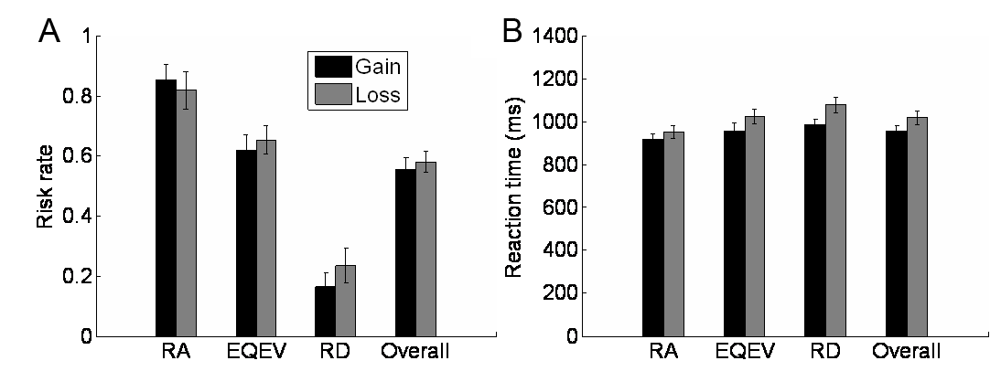
Fig. S1. Behavioral data in the Cups task. The risk rate data (A) suggest participants were sensitive to the EV manipulation (F(2,24) = 46,97, p < .001) and resistant to the frame bias (F < 1). Nevertheless, the response time data (B) suggest that participants intrinsically tended to make risky choices, especially under the Loss condition, because this behavioral rationality was achieved at the cost of extra effort. The response time is longer for the risky options with smaller EV than that with larger EV (F(2,24) = 11.49, p < .001), as well as for trials in the Loss domain than for trials in the Gain domain (F(1,12) = 9.70, p = .009).

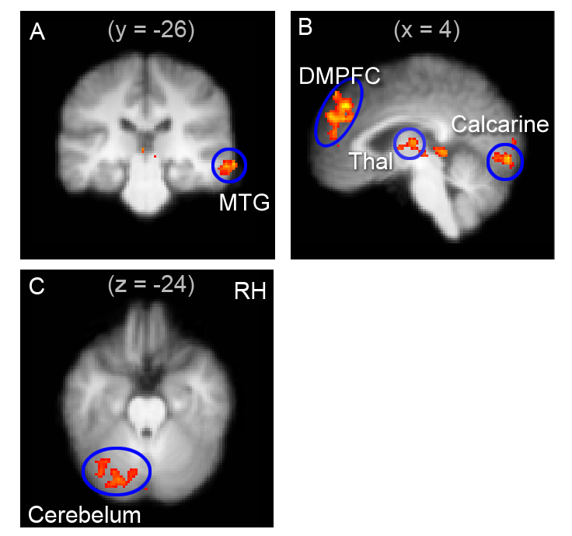Fig. S2. fMRI results for risk vs. safe choice. Regions with significant activation (Z > 2.3, whole-brain cluster-corrected at p < .05 using GRFT) were overlain on the coronal (A), sagittal (B) and axial (C) slices of a group mean structural image.

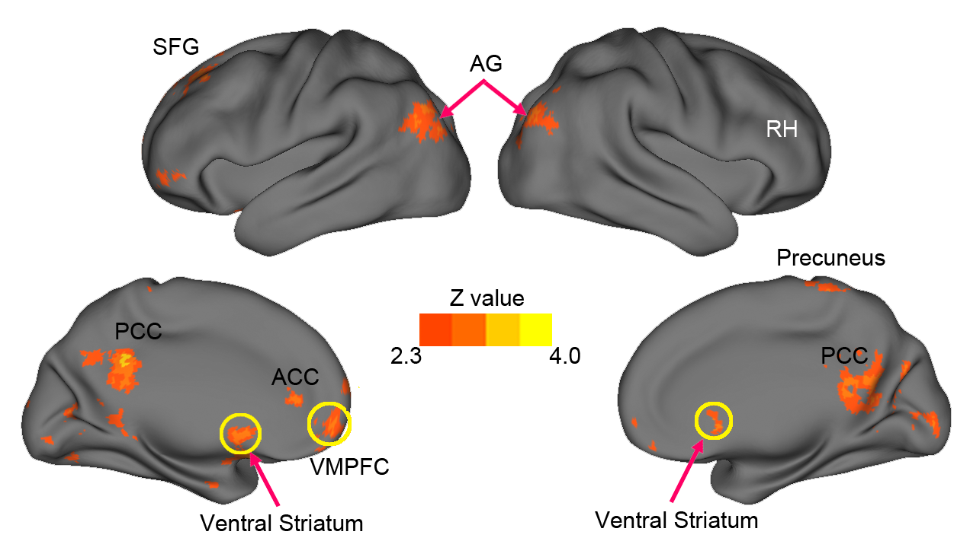

Fig. S3. fMRI results for win vs. loss outcome. Regions with significant activation (Z > 2.3, whole-brain cluster-corrected at p < .05 using GRFT) are rendered into the Probabilistic Average Landmark and Surface-based (PALS) atlas using the multifiducial mapping technique described by Van Essen. Cortical renderings were performed using CARET software (http://brainmap.wustl.edu). The top and bottom panels show the lateral and medial view, respectively.
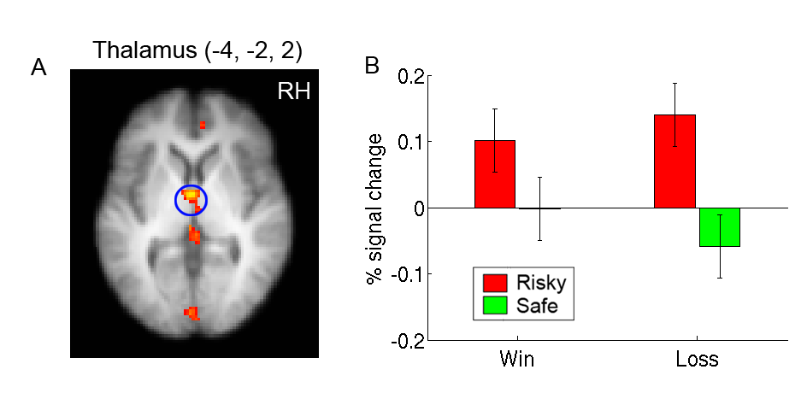
Fig. S4. fMRI results for Risky vs. Safe choice in the thalamus (A), The right panel (B) shows the plot of percentage signal change. ANOVA revealed a significant effect of risk (p =.0058), but no effect of reward valance or interaction (both p’s > .31).

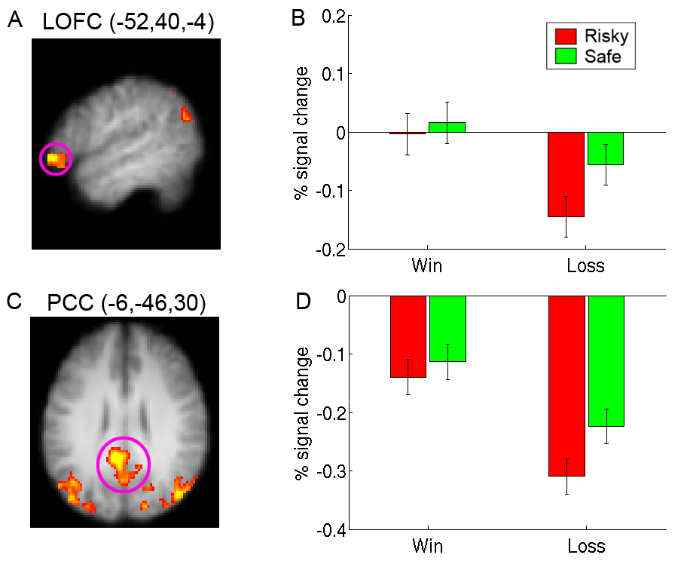Fig. S5. fMRI results for win vs. loss outcome in the left lateral orbital frontal gyrus (A) and posterior cingulate cortex (C). The right panel (B, D) show the plots of percentage signal change in each region. ANOVA revealed a significant effect of reward valence (Win > loss) in both regions (p = .01 and p <.001 for LOFC and PCC, respectively), PCC also showed a small effect of risk (safe > risky choices) (p = .04), no other effects or interactions were significant (all p’s > .14).

